**FREQUENCY SPECTRUM ANALYSIS AND APPLICATIONS**

ID : 201414070112



Mugahid Omer Hajeltoum Albadawy

School of Automation , UESTC

Chengdu , Sichuan , China

[Mugahid_omer@yahoo.com](mailto:Mugahid_omer@yahoo.com)

**Supervised By** : Prof. Jing Ran Lin

18 DEC 2014

**CONTENTS**

1. **INTRODUCTION**
2. **FOURIER SERIES**
3. **FREQUENCY SPECTRUM**

(3.1) Example of an Application

1. **FREQUENCY ANALYSIS**

(4.1)Selection of Sampling Frequency

(4.2)Vector Representation of a Cosine

(4.3)Fourier Transform

(4.3.1)Fast Fourier Transform

1. **IMPLEMENTATION OF THE FFT IN MATLAB**

CONCLUSION

APPINDEX

1. **INTRODUCTION**

Always the signal measured in surrounded area are in analog form and has magnitude and frequencies range so now the issue is how to analyze this spectrum to get the dominate frequency .

Consider a signal generated by a probe (such as a hot-wire anemometer) sensing the velocity in the wake of a circular cylinder. The velocity fluctuates with time because the flow is unsteady.

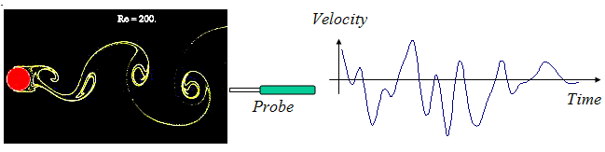

Imagine you are measuring this signal as part of an experiment to understand the flow and its effects. The portion of the velocity signal shown clearly contains important frequency information. We see fluctuations at several frequencies apparently connected to the passage of eddies over the probe and the frequency at which eddies are shed from the cylinder. If the cylinder were supported by a flexible structure, knowing this shedding frequency would tell us the frequency at which that structure would be excited and thus help us analyze its structural response. So this information is clearly valuable for several reasons, but how do we get it? How do we determine *what frequencies are in the signal*?

|  |
| --- |
|  |

1. **FOURIER SERIES**

a function has developed to generate a cosinusoidal (harmonic) signal {x} with the given amplitude xo , frequency f in Hz and the initial phase φo in degrees for the given time vector {t}, according to the equation

 (1)

In this Module you will use this function to generate signals that comprise a known blend of various harmonics to practice their decomposition into the frequency components with the Fourier Transform spectrum.

Notice that a sinusoid is the same as cosinusoid with the initial phase of -90o . The effect of summing more and more terms of a series of sinusoids in the time span of one second by applying the following pattern of amplitude: 1, 1/3, 1/5, 1/7, 1/9 etc and the corresponding pattern of frequency: 1, 3, 5, 7, 9 etc.

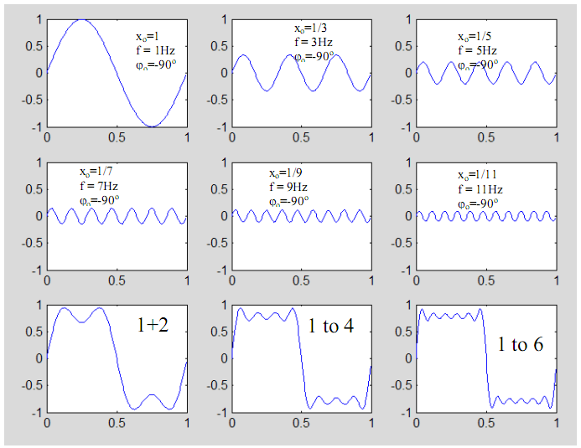

Figure 1 First six frequency components of a square wave

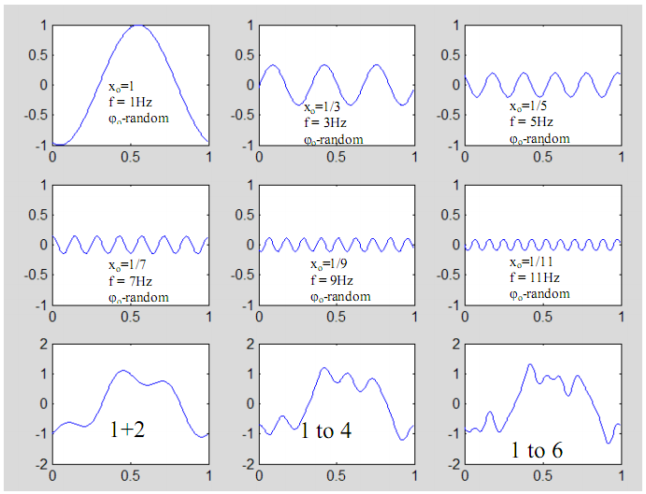

Figure 2 First six frequency components of a random signal



The summations of the first 2,4 and 6 terms for the two cases are illustrated in Figure 1 and Figure 2. Two cases are shown:

• Figure 1 - the initial phase is -90o for all cosinusoidal terms, i.e. signals start from 0 and are sinusoids. The combination produces a square wave as seen below for the sum of 100 components.

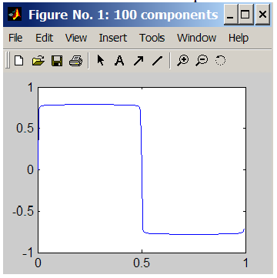

Figure 2 - the initial phase of each cosinusoid varies and is allocated from the uniform random distribution between –π and +π radians (i.e. -180o and 180o ), i.e. signals start randomly. The combination produces a random signal.

Figure 1 and Figure 2 are illustrations of the Fourier Theorem and the Fourier Series.

Fourier Series : A periodic function can be represented as a sum of infinite number of (co-) sinusoidal components at equally spaced frequencies with the interval of 1/T, where T is the period of the function, the so called Fourier Series.

1. **FREQUENCY SPECTRUM**

When harmonic components of a signal are known, the signal can be presented in a different way that highlights its frequency content rather than its time domain content. Introducing the third axis of frequency perpendicular to the amplitude-time plane the harmonic components can be plotted in the plane that corresponds to their frequencies. For example, a random signal similar to the one in Figure 2 can be presented as shown in Figure 3 in such a way that both time and frequency details are visible.

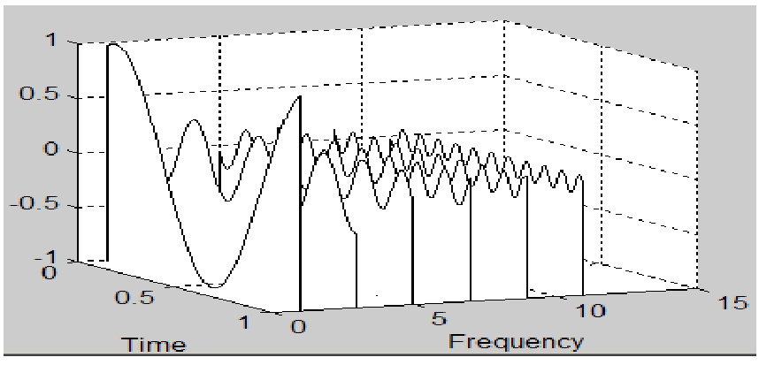

Figure 3 : Time-Frequency-Amplitude representation of a random signal

The graph in Figure 3 can be rotated in such a way that the time axis is perpendicular to the observer. This frequency domain view when the time axis is no longer visible and only positive values of magnitude of each sine are plotted, is called the magnitude spectrum.

Figure 4 depicts the magnitude spectrum of the signals shown in Figure 1, Figure 2 or Figure 3.

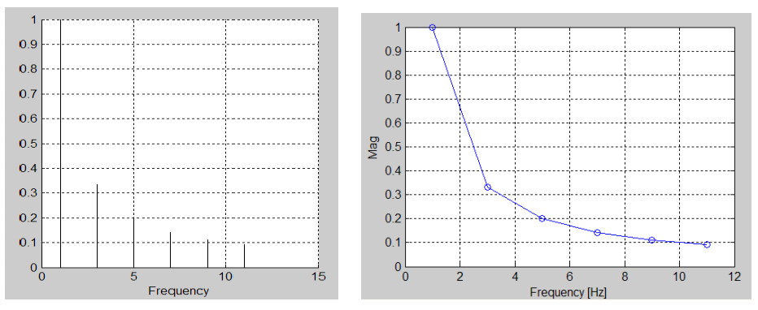

Figure 4: Magnitude spectrum

Magnitude spectrum is not sufficient to fully define the signal. The phase spectrum of each frequency component must be known in order to unambiguously describe it. It is clear now that a component of the spectrum at the given frequency must be described with two parameters. The pair of magnitude and phase is one example of these two parameters.

* 1. **Example of an Application**

An example of an automotive application of frequency spectrum is demonstrated in The roof of a car vibrates excessively at certain driving conditions. The vibrations signal measured with an accelerometer is complex and contaminated, and it is not clear what the cause of this resonance is. However the magnitude spectrum of acceleration reveals a peak at 30 Hz which, after some analysis, coincides with the RPM of one of the shafts in the gearbox which rotates at 1,800rpm at these driving conditions.

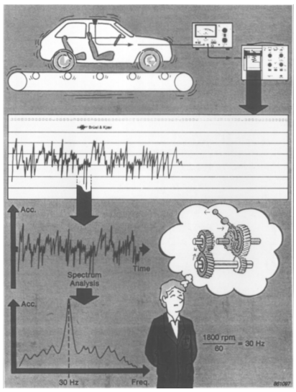

Figure 5 An automotive application of frequency spectrum (Brüel&Kjær "Structural Testing")

1. **FREQUENCY ANALYSIS**

In engineering practice signals are usually not described by mathematical functions but come from measurement acquired with a selected sampling interval Δt (its inverse is the sampling frequency or rate fs ). Thus the signal is not continuous but discrete. They may also be obtained from a simulation models, eg. in Matlab Simulink, which also produce discrete signals. The duration of a signal is finite and in most cases it will not be the same as the period required by the Fourier Theorem. The signal may not be periodic at all.

Due to these limitations:

*The purpose of frequency analysis is to devise a method to extract an estimate of frequency components which are not known a priori. The process is known as the Discrete Fourier Transform (DFT).*

Awareness of some concepts is necessary in order to understand the DFT or its special case, the Fast Fourier Transform (FFT).

* 1. **Selection of Sampling Frequency**
* Shannon Sampling Theorem. Aliasing

The choice of sampling frequency is arbitrary. The signal contains various frequency components to be detected. What are the pitfalls of selecting a "wrong" sampling frequency?

If the frequency to be detected is f and the sampling frequency is too low, i.e. fs <= 2f , a lower erroneous frequency will be perceived, as illustrated in Figure 6. The phenomenon is called the aliasing.

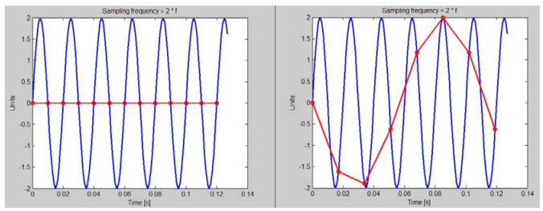

Figure 6 Illustration of the phenomenon of frequency aliasing

Figure 6 Illustration of the phenomenon of frequency aliasing

Shannon Sampling Theorem is formulated:

The measured signal must not contain frequencies above half of the sampling rate.

Frequency equal to half of the sampling frequency is the highest detectable frequency. It is called the Nyquist or folding frequency. The most effective way of preventing the aliasing is by filtering it with a low pass filter with the cut-off frequency less than half of the sampling rate.

* 1. **Vector Representation of a Cosine**

A two-dimensional vector in the complex plane is shown in Figure 7

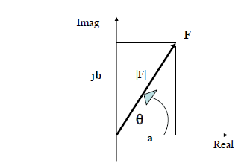

Figure 7: A vector in the complex plane with the imaginary axis pointing upwards

**F = |F| (**cos θ **+ j** sin θ **)**

Euler’s relationship

**e**jθ **= (**cos θ **+ j** sin θ **)**

**e**-jθ **= (**cos θ **- j** sin θ **)**

**F = |F| e**jθ

Although the complex notation and Euler's expression simplify the mathematics by explicitly removing trigonometric functions, they introduce an unwanted imaginary term.

As shown in Figure 8, on the axes rotated in such a way that the real axis is pointing upwards, the sum of the vector and its complex conjugate (i.e. a vector with imaginary part of opposite sign) is real. If these two vectors are counter-rotating with the same frequency in the complex plane, their sum remains real, change sinusoidally with time and the sum's magnitude is twice bigger compared to the component vector, as demonstrated in . The vectors rotate with a constant frequency but in the opposite

directions. The sign of the counter-rotating vector's frequency is opposite to the frequency of other vector. Since the positive angle is measured from the real axis to the imaginary, the anticlockwise rotating vector has a positive frequency. The frequency of the counter-rotating vector (in the clockwise direction) is negative.

Two counter-rotating vector

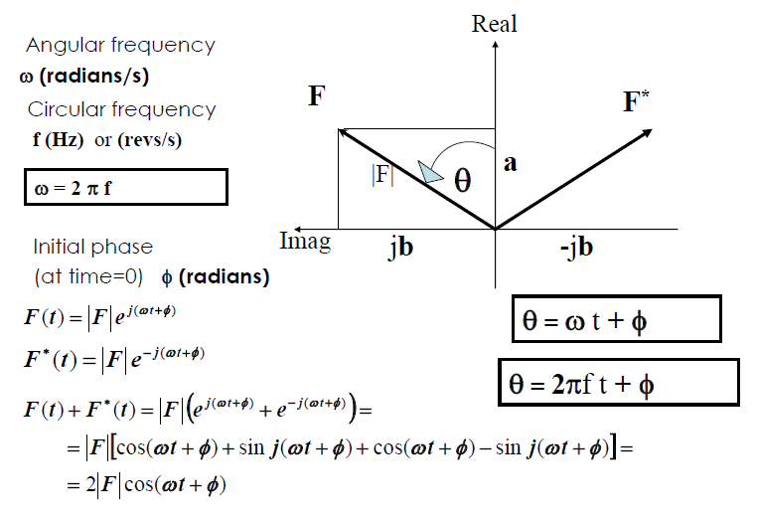

Figure 8 : A vector and its complex conjugate rotating in opposite directions (complex plane is rotated - real axis points upwards)

A cosine with the given amplitude and frequency can be represented by two counter-rotating vectors with that frequency with the initial phase φ = 0 and whose magnitudes is equal to half the cosine amplitude. For a sine φ = −90ο

* 1. **Fourier Transform**

As seen, a signal can be thought of as a collection of rotating vectors (or frequency components). In order to extract one of these vectors, one needs to make it stationary, mathematically speaking, for the duration of observation and then integrate over the time of observation. Multiplying a vector ***e j***(ω***t***+φ ) , which rotates with frequency ω, by ***e***−***j***ω***t*** produces a vector with the ωt eliminated, i.e. stationary vector: ***e j***(ω ***t*** +φ ) ***e*** − ***j***ω***t*** = ***e j***φ . Vectors with other frequencies continue to rotate and their integration (or summation) will be close to zero.

It is now clear that the continuous Fourier Transform of signal g(t), which extracts its component G at the frequency ω, is defined as



The equation is impractical and for a signal sampled at discrete times tn and over the finite duration kΔt, the so called Discrete Fourier Transform (DFT) is used



In practice, the circular frequency f in Hz is used instead of ω in rad/s. For such a case



These Fourier Transform equations must be applied to both the positive and the negative frequency.

When f= 0 the sum degenerates to the sum of the values in the signal which is real. In order to produce the mean value, the result needs to be divided by the number of points, k, in the signal. The same scaling needs to be applied to all frequency components of the spectrum in order to produce the correct estimate of the magnitude. At f= 0 the so called DC-value (or the mean value) of the signal is obtained. In many cases in engineering practice the DC value is, or should be 0 even if a measurement does not indicate so, e.g. the mean acceleration of a vibrating and stationary object.For a signal sampled with the sampling rate fs , due to the limitation imposed by the Shannon Theorem, components of the spectrum can only be extracted for frequencies between



or between the negative and positive Nyquist frequency. The equi-spaced components are at discrete frequencies and are separated by.



The Δf is called the frequency or spectral resolution. The +/-Nyquist frequency components of the spectrum are equal the same and are real as their rotating vectors always appear at the same location along the real axis, irrespective of the sign of frequency. It is important to notice that the Δf depends solely on the duration of observation (or measurement) T, i.e. the longer the duration the better (the smaller) the resolution. For the same number of points k in the sample the resolution can be improved (reduced) by having a worse time resolution Δt or a slower sampling frequency fs,

* + 1. **Fast Fourier Transform (FFT)**

The Fast Fourier Transform (FFT) is an algorithm for calculation of the DFT. The FFT algorithm applies only to signals comprising a number of elements which is equal to 2m (e.g. 28 = 256, 210=1024 etc.). Its main advantage is that it significantly reduces the computation time by a factor of the order m/log2m , i.e. more than 100 times for a sample of 1024 elements.

From the earlier discussion it is clear that the FFT should return a set of complex numbers, with exception of the spectral components at f=0 and f=fs/2 (the Nyquist frequency), which are both real. The number of FFT elements is equal to the size of

the time sample. The second half of these complex numbers corresponds to negative frequencies and contains complex conjugates of the first half for the positive frequencies, and does not carry any new information.

* **General Comments on FFT**

In order to correctly interpret the results of FFT, one must understand how FFT returns the results of the transform. The following is common to most implementations of FFT

Assuming that the number of points k, being a power of 2, was sampled with frequency fs = 1/Δt then

• The frequency resolution Δf = fs/k.

• The maximum frequency of the spectrum is the Nyquist frequency = fs/2.

• Since the FFT only does the summation of terms, the values returned by FFT must be scaled by dividing them by the number of points, k.

FFT returns k complex numbers with spectral components as follows:

• The first item is for f=0. Since it has to be real, its imaginary component is 0.

• The next k/2 items are for all positive frequencies in increasing order from Δf , 2Δf, 3Δf,…, (k/2-1)Δf, (k/2)Δf or fs/2.The element for the Nyquist frequency is real and is shared with the one for f = -fs/2, since they are equal.

• The next k/2-1 elements contain the negative frequency components. They are also placed in mathematically

increasing order from the most negative frequency f= -(k/2-1)Δf until f = -Δf. In other words, they are sorted from maximum negative to minimum negative frequency. In this sense they appear to be in reverse order of frequency.

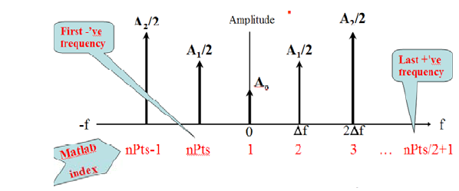

Figure 9: Location of FFT elements in Matlab.

* **Folding FFT Spectrum into a One-Sided spectrum**

The negative frequency components are there for mathematical reasons. The spectrum is conjugate even and, as the result, the magnitude spectrum is even, i.e. symmetrical around f=0. Such a spectrum is called two-sided.

For practical reasons we are interested in a presentation of the spectrum for positive frequencies only, the so called one-sided spectrum, similar to Figure 4. However we need to compensate the effect of ignoring the negative frequencies, by multiplying all positive frequency components by 2 (the two counter-rotating vectors are half-size). This process of converting from one-sided to two-sided spectrum is called **the folding**. An algorithm for folding FFT spectrum and calculating and plotting a one-sided magnitude spectrum is depicted in Figure 10.



Figure 10. Algorithm for folding the FFT spectrum and producing a magnitude spectrum

1. **IMPLEMENTATION OF THE FFT IN MATLAB**

To understanding the FFT algorithm a sampled sinusoidal signal will be generate with known amplitude, frequency and phase, and then subject it to FFT and study its behavior to recover the characteristics of the signal.

We can choose :

amplitude = 2; frequency = 80; phase = 0; samplingFrequency = 800;

figure 11 show the signal and sampling points

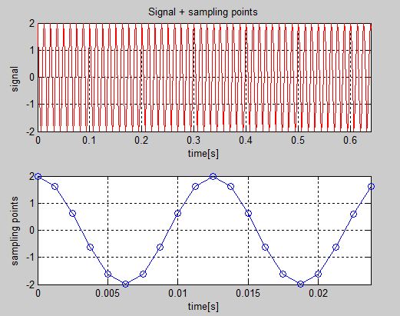

Figure 11. generated signal and its first 20 points

to retrieve the signal, subject it to the FFT and plot the raw, un scaled real and imaginary components

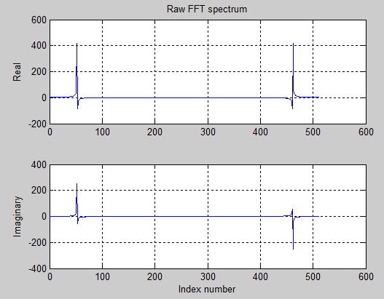

Figure 12. Real and imaginary components of FFT spectrum as returned by fft()

Now we can fold the spectrum according to the algorithm in Figure 10 although some alternative steps will be taken. The indexNyquist is the same as the number of points in the one-sided spectrum that we want to keep.

Figure 13 show the magnitude spectrum and the frequency value after recovery .

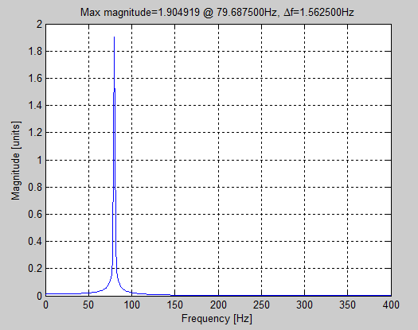

Figure 13. magnitude spectrum

CONCLUSION

After reviewing this report we find that the frequency spectrum is very important in real world , but the computer works with discrete signal , for that reason the scientist drive mathematical formulas to analyze and recover the signal to its original form .

After recovering the signal in the simulated program we find that calculated values deviated with a few error from the ideal value , the calculated values are 1.904919 unit and 79.6875 Hz for the magnitude and the frequency respectively .

APPENDIX

Simulated program

amplitude=2;

phase=0;

frequency=80;

sfrequency=800;

numberofpoints=2^9;

dt=1/sfrequency;

time=(0:numberofpoints-1)'.*dt;

gfunction=amplitude*cos(2*3.14*frequency*time+phase);

% Figure 11. generated signal and its first 20 points

figure

subplot(2,1,1)

plot(time,gfunction,'r')

v=axis;

v(2)=time(end);

axis(v)

grid on

ylabel('signal ')

xlabel('time[s]')

title('Signal + sampling points')

subplot(2,1,2)

plotend = 20;

plot(time(1:plotend),gfunction(1:plotend),'o-')

v=axis;

v(2)=time(plotend);

axis(v)

grid on

ylabel('sampling points')

xlabel('time[s]')

%Figure 12. Real and imaginary components of FFT spectrum as returned by fft()

spectrum = fft(gfunction,numberofpoints);

figure

subplot(2,1,1)

plot(real(spectrum))

grid on

ylabel('Real')

title('Raw FFT spectrum')

subplot(2,1,2)

plot(imag(spectrum))

grid on

ylabel('Imaginary')

xlabel('Index number')

%Figure 13. magnitude spectrum

indexNyquist = (numberofpoints/2)+1;

spectrum = spectrum(1:indexNyquist);

spectrum = spectrum/numberofpoints;

spectrum(2:end) = 2 * spectrum(2:end); %compensate for truncating the negative frequencies

%Calculate the magnitude

magnitude = abs(spectrum); %abs for complex numbers returns their magnitude

df = sfrequency/numberofpoints; %frequency resolution

frequencyAxis = [0:indexNyquist-1]'*df;

figure

plot(frequencyAxis, magnitude) %plot in a new figure

grid on

xlabel('Frequency [Hz]')

ylabel('Magnitude [units]')

[magMax,indexMax] = max(magnitude);

freqMax = frequencyAxis(indexMax);

%Display in title

title(sprintf('Max magnitude=%f @ %fHz, \\Deltaf=%fHz', magMax, freqMax,df))